**UNIVERSITY AMERICAN COLLEGE SKOPJE**

**SCHOOL OF COMPUTER SCIENCE AND INFORMATION TECHNOLOGY**



Course

**DATABASES**

**Centralized Management and Tracking:**

**Design and Implementation of a Satellite Database**



**Student:**  Darko Ivanoski

**ID:** 4660

**Instructor:**  *Venera Gudachi, PhD*

**Assistant:** Igor Janchev, BSc

**Academic year 2023/2024**

**Contents**:

1. Introduction: A comprehensive Satellite Tracking Database 4

2. E-R diagram 4

3. Diagram of tables 5

4. Documentation of tables 6

5. References 7

**List of figures**

Figure 1. E-R Diagram of Satellite Tracking Database 4

Figure 2. Diagram of Tables for Satellite Tracking Database 5

# Introduction: A comprehensive Satellite Tracking Database

The exponential growth of satellites orbiting Earth necessitates robust systems for tracking their location, health, and mission status. This project delves into the design and implementation of a satellite tracking database built using SQL Server Management Studio 2019. This centralized repository offers functionalities critical for diverse applications. Imagine a satellite communications company leveraging this database. It would streamline management of crucial details like satellite identification, launch information, and orbital data.

This approach eliminates data redundancy and fosters data integrity within the database. Similarly, space research institutions can utilize the database to monitor specific satellites. They can track the performance of onboard scientific instruments and monitor experiment progress. Amateur astronomers can also benefit immensely. By querying the database for satellites visible from their location, they can plan observation sessions and track intriguing celestial objects.

# E-R diagram

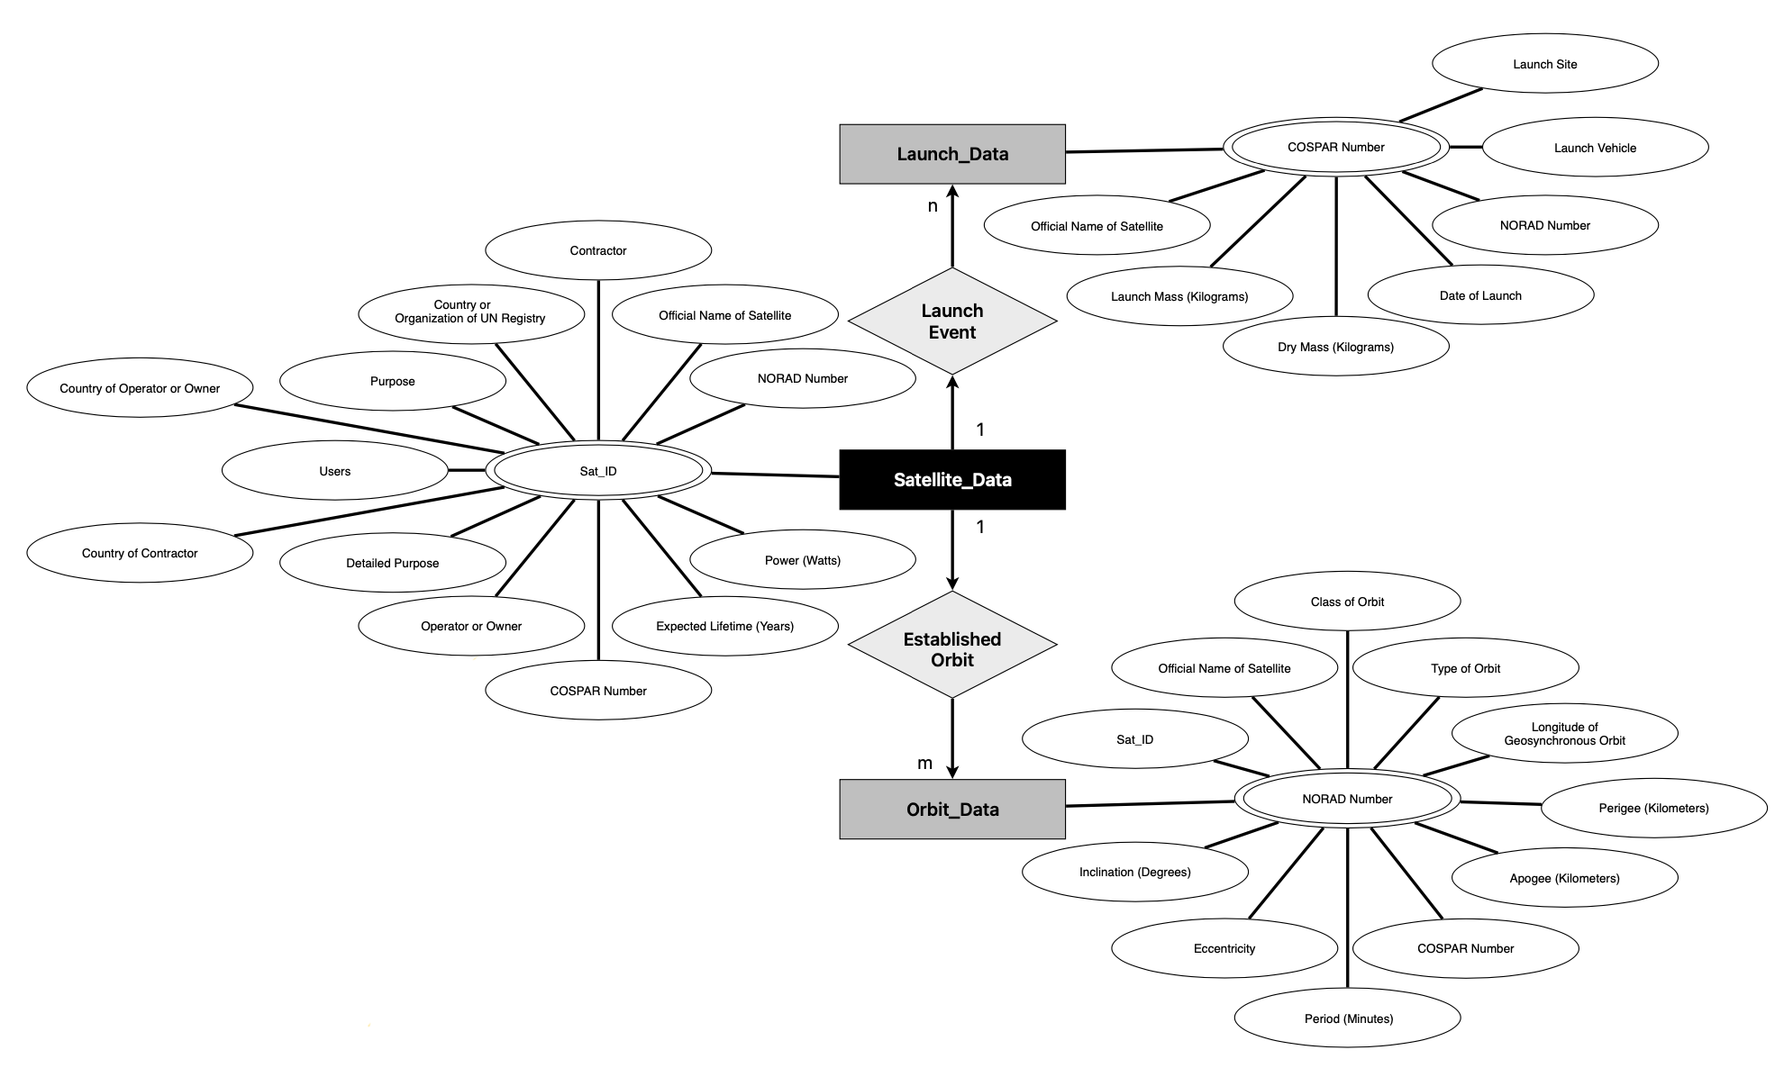

### Figure 1. E-R Diagram of Satellite Tracking Database

# Diagram of tables

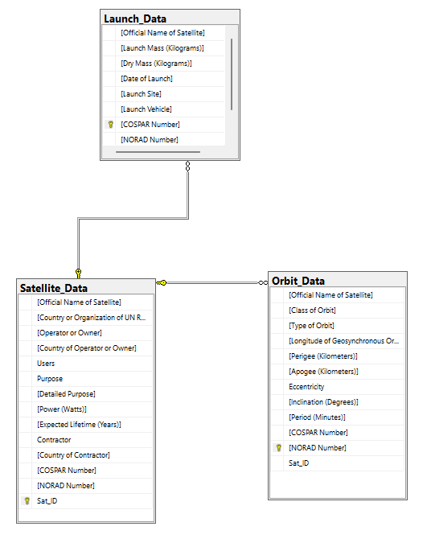

### Figure 2. Diagram of Tables for Satellite Tracking Database

# Documentation of tables

This document outlines the structure and purpose of each table within the tracking database created in SQL Server Management Studio 2019.

1. **Satellite_Data**

**Purpose**: This table serves as the central repository for information about each satellite.

**Columns:**

* [Official Name of Satellite] VARCHAR(30): Official name of the satellite.
* [Country or Organization of UN Registry] VARCHAR(50): The country or organization that officially registered the satellite with the United Nations.
* [Operator or Owner] VARCHAR(50): The entity that controls or owns the satellite.
* [Country of Operator or Owner] VARCHAR(20): The nationality of the operator or owner.
* [Users] VARCHAR(10): Types of users.
* [Purpose] VARCHAR(20): The general function of the satellite (e.g., communication, Earth observation).
* [Detailed Purpose] VARCHAR(50): More specific description of the satellite's mission.
* [Power (Watts)] VARCHAR(10): The power output of the satellite.
* [Expected Lifetime (Years)] VARCHAR(10): The expected operational lifespan of the satellite.
* [Contractor] VARCHAR(20): The company that built the satellite
* [Country of Contractor] VARCHAR(15): The nationality of the company that built the satellite.
* [COSPAR Number] VARCHAR(20): Unique identifier assigned by the Committee on Space Research (COSPAR).
* [NORAD Number] INT: Unique identifier assigned by the North American Aerospace Defense Command (NORAD).
* [Sat_ID] INT IDENTITY(1, 1): Auto Incrementing Primary Key for the Satellite-Data Table.

1. **Launch_Data**

**Purpose:** This table stores details about the launch event for each satellite.

**Columns:**

* [Official Name of Satellite] VARCHAR(20): Official name of the satellite.
* [Launch Mass (Kilograms)] VARCHAR(20): Mass of the satellite at launch.
* [Dry Mass (Kilograms)] VARCHAR(20): Mass of the satellite post launch.
* [Date of Launch] VARCHAR(20): Date and time of the launch event.
* [Launch Site] VARCHAR(20): Location from which the satellite was launched.
* [Launch Vehicle] VARCHAR(20): Rocket or launch system used to deploy the satellite.
* [COSPAR Number] VARCHAR(20): Unique identifier assigned by the Committee on Space Research (COSPAR), Primary Key for the Launch_Data table.
* [NORAD Number] VARCHAR(10): Unique identifier assigned by the North American Aerospace Defense Command (NORAD).
* [Sat_ID] INT IDENTITY(1, 1): Foreign Key Referencing the table Satellite_Data.

1. **Orbit_Data**

**Purpose:** This table stores specific details about the orbital path of each satellite.

**Columns:**

* [Official Name of Satellite] VARCHAR(20): Official name of the satellite.
* [Class of Orbit] VARCHAR(10): Orbital classification of the satellite (e.g., geosynchronous, low-Earth orbit).
* [Type of Orbit] VARCHAR(20): Type of the orbit (e.g Sun-Synchronous, Non-Polar Inclined).
* [Longitude of Geosynchronous Orbit (Degrees)] VARCHAR(15): This field stores the longitude (in degrees) of a satellite positioned within a geosynchronous orbit.
* [Perigee (Kilometers)] INT: Closest point of the orbit to Earth (in kilometers).
* [Apogee (Kilometers)] INT: Farthest point of the orbit from Earth (in kilometers).
* [Eccentricity] NVARCHAR(15): Measure of the orbit's elongation (0 for perfect circle).
* [Inclination (Degrees)] NVARCHAR(15): Angle of the orbit relative to Earth's equator.
* [Period (Minutes)] NVARCHAR(15): Time taken to complete one revolution around Earth.
* [COSPAR Number] VARCHAR(20): Unique identifier assigned by the Committee on Space Research (COSPAR).
* [NORAD Number] INT): Unique identifier assigned by the North American Aerospace Defense Command (NORAD). Primary Key for the Orbit_Data table.
* [Sat_ID] INT IDENTITY(1, 1): Foreign Key Referencing the table Satellite_Data.

**Comment:** Due to the inaccurate categorization of certain values within the dataset, some values are impossible to precisely target (e.g., Expected Lifetime (Years): “1.5yrs” followed by “15”).

# References

1. Union of Concerned Scientists (2017), Active Satellites in Orbit Around Earth <https://www.kaggle.com/datasets/ucsusa/active-satellites> (last accessed on 02.05.2024)